Rikiesha Metzger

Duchamp: The Undercover Utopian and His Readymade Art
As a child develops and is able to communicate with words, they become more independent providing a space for them to separate from their parent. The child no longer depends entirely on their parent for their needs thus, creating a new reality in the child’s identity as they begin to discover the world through a new lens. In a way, this new lens is what pushes artists to discover a utopian dream through their original works. In this paper, I will discuss how utopianism plays a role in the development of a hidden identity in Marcel Duchamp, and his Readymade Fountain. Duchamp uses the term Readymade to describe works of art created using manufactured objects that require little to no modification. This essay defines utopianism as a place of complete satisfaction according to Duchamp’s own beliefs and his intended outcome as highlighted in his essay, The Richard Mutt Case. Gropius’ The Theory and Organization of the Bauhaus, “a school with a commitment to ‘release the creative powers of the student’ . . . to be assured of a productive outcome through contacts with industry”(309); and Huelsenbeck and Hausmann’s What Is Dadaism, are used as supporting text to establish the foundation upon which this utopian claim is built. Although this paper highlights Huelsenbeck and Hausman’s (H/H) essay, What is Dadaism, I will use Dadaism as defined by Huelsenbeck in his essay entitled, First German Dada Manifesto. Huelsenbeck records, “[t]he word Dada symbolizes the most primitive [simple, basic] relation to the reality of the environment; with Dadaism a new reality comes into its own” (258). While I am of the opinion that Duchamp would not consider himself “a utopian,” I will argue that his hidden identity behind the pseudonym 'R. Mutt, his Fountain sculpture, and his ideas behind Readymade objects, aligns with utopian ideologies therefore categorizing Duchamp as a utopianist himself.
Duchamp is an artist from the early twentieth century, who is equally known both for his paintings, and Readymade “sculptures,” especially his Readymade entitled Fountain. Like the movement that is present in Duchamp’s Cubism paintings, he abandons his life as a painter and emigrates to America (252). While Cubism style paintings trap artists inside the box, Dadaism makes room for them to create freely outside the box. Is it possible that Duchamp wants to recreate his life as an artist to become a “new creation,” different from his previously known painterly self to hide behind a hidden identity; exploring a place where he believes can achieve complete satisfaction? With Cubism and Dadaism simultaneously at the forefront of the Modern movement, Duchamp ceases the opportunity to move with a similar impetus at the turn of his life’s events. Duchamp devises a clever plan to create for himself a world in which he decides “what goes” which is to say he creates his own form of utopia although Duchamp does not make this claim verbatim. In his transitional process, Duchamp uses the pseudonym R Mutt to conceal his true identity. R Mutt, becomes the embodiment of an utopianist idea.
As we refer back to our definition of utopianism as defined in this project, we explore several ways in which Duchamp experiments with his “secret identity” to satisfy the requirements needed to align with utopian ideologies. “In 1917, under the pseudonym ‘R. Mutt’, [Duchamp submits] a urinal to the open exhibition of the Society of Independent Artists in New York, with the title ‘Fountain’. The piece was refused entry (as he no doubt intended)” (Duchamp 252). By entering a work under an alias, we find Duchamp’s first example of how he experiments with his “secret identity” to support the claim that Duchamp is an undercover utopian. Gropius states “[n]o longer can anything exist in isolation. We perceive every form as the embodiment of an idea, every piece if work as a manifestation of our innermost selves” (309). Although not explicitly mentioned in his essay, Duchamp’s change in his life events brings him to the complete satisfaction knowing that he does not have to use his own name to be recognized as an artist.
In a similar way, Duchamp’s new identity makes room for his new artistic practice as he establishes his rules of engagement with his Readymade art, Fountain. Duchamp’s Readymade art is found in the Dadaism period, and in a way is in line with H/H’s essay, What is Dadaism? Duchamp unknowingly establishes himself as a utopian when he writes “[t]hey say any artist paying six dollars may exhibit. . . what were the grounds for refusing Mr Mutt’s fountain” (252). The exhibition could potentially help Duchamp's case as it offers him an opportunity to introduce the premise from which he builds his new found artistic framework with his Readymade objects. In the first line of What is Dadaism, the manifesto states “Dadaism demands” (Huelsenbeck 259). Like H/H, Duchamp demands to know the rationale behind why the R Mutt piece is rejected if “any artist” may exhibit as long as they pay the fee. “The First German Dada Manifesto emphasize[s] ‘movement and struggle’. The remaining requirement for a ‘program of action’ is fulfilled [in the current, What is Dadaism] manifesto” (259). Duchamp’s Readymade objects illuminate the utopian ideology of “movement and struggle,” in which he breaks barriers with his work entitled Fountain, which later accomplishes his “program of action” in his demands to have his work recognized as art.
In grappling with the idea of “what constitutes art” this essay demonstrates how Duchamp’s urinal “fountain” exemplifies the Bauhaus unification of ideas that strives for inclusivity of all individuals. Gropius writes “[t]rue creative work can be done only by the man whose knowledge and mastery of the physical. . . equip him to give life and shape to his inner vision (311). Consequently, the Bauhaus utopian impulse underlined with Duchamp’s Fountain sculpture becomes his second example in which he presents his Readymade object to the eye of the public offering a new way to perceive art. Duchamp states “[w]hether Mr Mutt with his own hands made the fountain or not has no importance. He CHOSE it. He took an ordinary article of life, placed it so that its useful significance disappeared under the new title and point of view- created a new thought for that object” (252). According to Duchamp, the art does not have to start with the artist making the work with his or her hands, he implies that “art can be what it is,” in its ordinary form as long as the artist chooses it. Contrary to Gropius’ Bauhaus, and H/H’s What is Dadaism, Duchamp formulates his views on the possibilities of art in a less programmatic way.
Although H/H demands are very direct and structured, they spell out their ideas to what Dadaism demands. A “utopian character is evident” as H/H uses the manifesto’s demands to fulfill this essay’s definition of Dadaism (259). Admittedly, H/H’s detailed structure is in contrast to Duchamp’s more organic approach, and in a way Duchamp’s utopian identity begins to unfold all the more. Duchamp writes “[s]ome contented [the Fountain] was immoral, vulgar. . . Mr Mutt’s fountain is not immoral, that is absurd, no more than a bathtub is immoral” (252). Combined with the fact that with dadaism a new reality comes into its own, R Mutt’s urinal is in line with the dada’s artistic standards even in the event that an object is found in everyday utilitarian use. Thus furthering the argument that the urinal qualifies as art because “its useful significance changed under position” even if it is in a less programmatic way. Duchamp’s question to “what constitutes art” is established under his secret identity as Mr Mutt and his ideas behind his Fountain sculpture is in line with utopian ideologies.
Despite Duchamp’s pushback on his Readymade Fountain, he uses his beliefs and the intended outcome of his work as justification to defend his Readymade Fountain. Duchamp’s Readymade object is his attempt to challenge those who are critical of his work by debunking the negative connotations and defining his own artistic style. To further the claim that Duchamp is a “top-secret” utopian, let us compare his Readymade piece entitled, Bicycle Wheel (large bicycle wheel situated through the middle of a stool), dated 1913 to Gropius’ Bauhaus utopian theory. In a way, the sculpture brings stability to the space as the bicycle wheel is precisely located in the center of the stool creating its own momentum of balance. Gropius writes “[t]he dominant spirit of our epoch is already recognizable although its form is not yet clearly defined. The old dualistic world-concept which envisaged the ego in opposition to the universe is rapidly losing ground. In its place is rising the idea of a universal unity in which all opposing forces exist in a state of absolute balance” (Gropius 309). As Gropius’ words are eloquently articulated through his utopian ideas behind his dualistic world-concept through writing, Duchamp fabricates Gropius' sentiments through the modification of his Readymade Bicycle Wheel. By default, Duchamp’s Bicycle Wheel here again places him in the category of a utopian.
In conclusion, this essay uses an intertextual exploration of the essays, The Richard Mutt Case, What is Dadaism? and The Theory and Organization of the Bauhaus as found in this paper, to bring together the unification of ideas to establish Duchamp’s “hidden identity” as a utopian. Throughout this essay, I bring multiple perspectives, uncovering Duchamp’s hidden identity through a new theoretical lens which helps to support my claim and reveals Duchamp’s true identity as a utopian. By reviewing Duchamp’s essay The Richard Mutt Case, combined with my discoveries from Gropius and H/H programmatic structure, I break through the barriers that cover Duchamp’s utopian ideologies. A sudden change in Duchamp’s life events brings him to complete satisfaction during his dada period in which he uses the pseudonym, R Mutt knowing that he does not have to use his own name to be recognized as an artist thereby reaffirming my argument. In Duchamp's attempts to hide behind his R Mutt alias, his Fountain sculpture, and his ideas behind Readymade objects it becomes apparent that his true identity is a utopian. Despite how critics may find Readymades such as Duchamp’s Fountain to be ‘immoral, plagiarism, or simply a piece of plumbing, Duchamp’s intentions are to change the way we view ordinary articles of life. Readymade objects are forever shifting perspectives in this timeless theoretical debate on “what constitutes art.”

Work Cited
Duchamp, Marcel. “The Richard Mutt Case.” Art in Theory: 1900-2000, edited by Harrison &
Woods, Blackwell Publishing, 2002, p 252.

Gropius, Walter. “The Theory and Organization of the Bauhaus.” Art in Theory: 1900-2000,
edited by Harrison & Woods, Blackwell Publishing, 2002, pp 309-314.

Huelsenbeck, Richard. “First German Dada Manifesto.” Art in Theory: 1900-2000, edited by
Harrison & Woods, Blackwell Publishing, 2002, pp 252-259.

Huelsenbeck, Richard and Raoul Hausmann. “What is Dadaism and what does it want in
Germany?” Art in Theory: 1900-2000, edited by Harrison & Woods, Blackwell
Publishing, 2002, pp 259-260.

Appendix

Fig. 2

Fig. 1

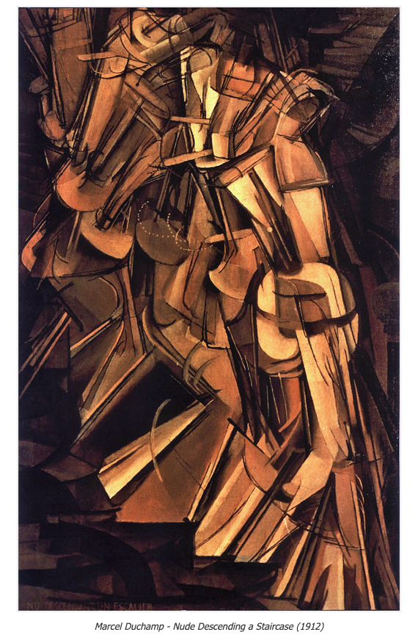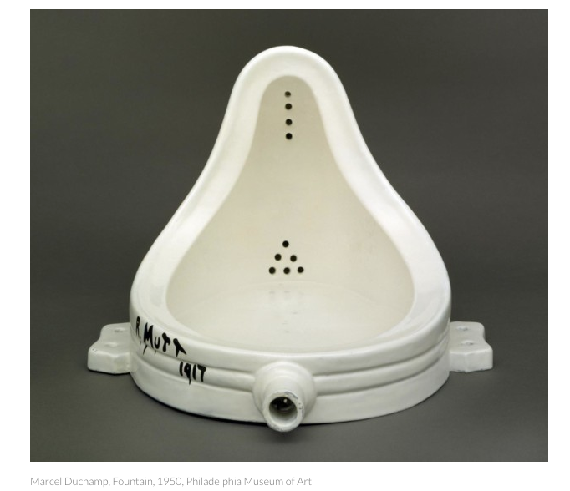
Marcel Duchamp- Nude Descending a Staircase (1912) Marcel Duchamp- Fountain Replica (1950) Philadelphia Museum of Art

Fig. 3

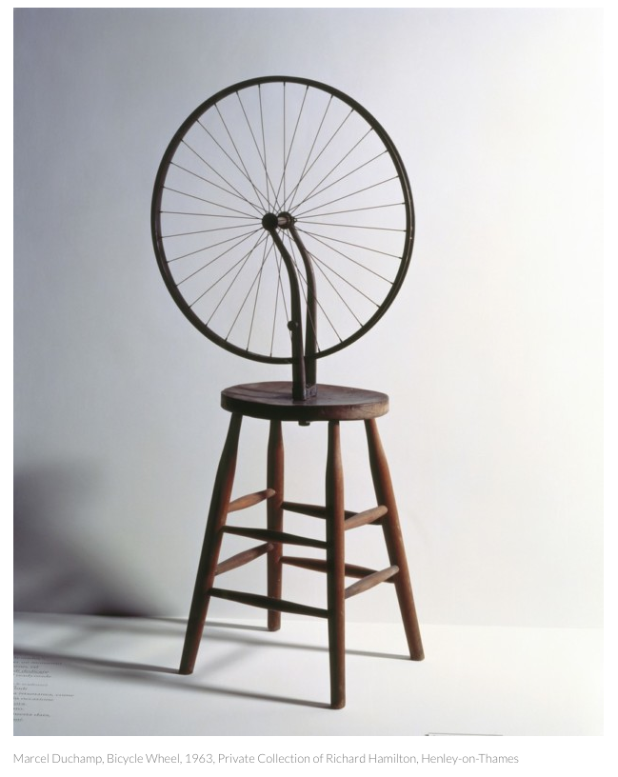
Marcel Duchamp- Bicycle Wheel (1963), Private Collection of R Hamilton

Rikiesha Metzger
701 Art and Theory
Outline
Professor Simonetta Mono
June 7, 2020

Outline

Topic: In this paper I will discuss how utopianism plays a role in the development of a hidden identity in Duchamp himself, his ideas behind Readymade objects and his sculpture entitled, Fountain.

Identify your “cast of characters”: This essay defines utopianism as a place of complete satisfaction according to Duchamp’s own beliefs and his intended outcome as highlighted in his essay, The Richard Mutt Case. Gropius’ The Theory and Organization of the Bauhaus, “a school with a commitment to ‘release the creative powers of the student’ . . . to be assured of a productive outcome through contacts with industry”(309); and Huelsenbeck and Hausmann’s What Is Dadaism, are used as supporting text to establish the foundation upon which this utopian claim is built. Although this paper highlights Huelsenbeck and Hausman’s (H/H) essay, What is Dadaism, I will use Dadaism as defined by Huelsenbeck in his essay entitled, First German Dada Manifesto. Huelsenbeck records, “[t]he word Dada symbolizes the most primitive [simple, basic] relation to the reality of the environment; with Dadaism a new reality comes into its own” (258).

Argument: While I am of the opinion that Duchamp would not consider himself “a utopian,” I will argue that his hidden identity behind the pseudonym 'R. Mutt, his Fountain sculpture, and his ideas behind Readymade objects, aligns with utopian ideologies therefore categorizing Duchamp as a utopianist himself.

- Duchamp is known as painter and sculptor however, Duchamp is an “undercover” utopian. Duchamp abandoned painting to produce ‘Readymades’ (sculptures)
- R. Mutt is the name Duchamp used to enter his work to the open exhibition of the Society of Independent Artists in New York, in 1917.
- Is it possible that Duchamp wants to recreate his life as an artist to become a “new creation,” different from his previously known painterly self to hide behind a hidden identity.
- Gropius states “[n]o longer can anything exist in isolation. We perceive every form as the embodiment of an idea, every piece if work as a manifestation of our innermost selves” (309).

- Duchamp’s new identity makes room for his new artistic practice as he establishes his rules of engagement with his Readymade art, Fountain.
  - Duchamp’s Readymade art is found in the Dadaism period, and in a way is in line with H/H’s essay, What is Dadaism?
  - In the first line of What is Dadaism, the manifesto states “Dadaism demands”(Huelsenbeck 259).
  - Duchamp’s Readymade objects illuminate the utopian ideology of “movement and struggle.
  - The Bauhaus utopian impulse underlined with Duchamp’s Fountain sculpture becomes his second example.

- Readymades under Dadaism helps to reveal Duchamp’s secret identity as a utopian.
- His Readymade objects are works which stem from items found in everyday utilitarian uses for example, the urinal which is given the new name, Fountain.
- Duchamp’s utopian identity begins to unfold all the more with his readymade objects.
- Admittedly, H/H’s detailed structure is in contrast to Duchamp’s more organic approach and in a way, Duchamp’s utopian identity begins to unfold all the more.
- Duchamp’s Bicycle Wheel in comparison to Gropias’ writings, situates he text with the art. “The dominant spirit of our epoch is already recognizable although its form is not yet clearly defined (Gropias 309).

- Limits: Three text made me consider what the most important points were that would help my aregument.
- I am under the assumption that Duchamp used this given name in his cubist period since, the article only focuses on “The Richard Mutt Case”
- I set aside detailed information about the Bauhaus itself, but make mention that has a programmatic structure.
- In the essay, “What is Dadaism” I had to look at the first manifesto to see how Huelsenbeck defined “Dadaism.”

- Challenges:
  - It is possible that Duchamp under other circumstances would not be considered a utopian.
  - With page restrictions, I do not go into details about the programmatic structures of “What is Dadaism” nor Gropius’ Bauhaus.
  - Unpack and intertextualize all text to make sure my argument is clear.

- Summary: Duchamp uses his hidden identity to hide behind the pseudonym 'R. Mutt, his Fountain sculpture, and his ideas behind Readymade objects, aligns with utopian ideologies therefore categorizing Duchamp as a utopianist himself.
- Through an intertextual exploration of the essays, The Richard Mutt Case, What is Dadaism?, and The Theory and Organization of the Bauhaus as found in this paper, I bring together the unification of ideas to establish Duchamp’s “hidden identity” as a utopian.
- Throughout this essay, I bring multiple perspectives, uncovering Duchamp’s hidden identity through a new theoretical lens which helps to support my claim and reveals Duchamp’s true identity as a utopian.
- My thesis is important because it helps Duchamp’s audience(s) to change the way we view ordinary articles of life. We learn that Readymade objects has helped artists and critics alike to see through a new lens and that the Readymade is forever shifting perspectives in this timeless theoretical debate on “what constitutes art.”

