Rikiesha Metzger

Shifting Perspectives in Becoming: See Her in the Other
“Lights, camera, action,” echoes the all too familiar phrase in the cinematic world as the director of a production signals to their team that it is time to “get the ball (reel) rolling.” It is with a similar impetus, like stills that make up the frames of a cinematographic film, this exposition focuses on the following: the dual role of subjectivity with themes that address identity as well as a non-individualistic idea of selfhood as expressed in the artwork of Harmonia Rosales (a Chicagoan woman of color) and her painting The Creation of God; Emmanuel Levinas’s The Interview, Jacques Lacan’s The Four Fundamental Concepts of Psycho-Analysis, and two works from Amelia Jones’s The Feminism and Visual Culture Reader: the first is the “Introduction and Conclusion to the Guerilla Girls Bedside Companion to the History of Western Art,” where The Guerilla Girls (a group of all female artivists wear gorilla masks as a political act of solidarity through anonymity); the second work is “From Ways of Seeing,” written by John Berger (a white male artist known for his contributions as an art critic); explores is the question of the ‘becoming’ of Subjectivity in the areas of identity and a non-individualistic idea of selfhood introduced by way of desire, language, and ‘otherness.’
Subjectivity is established on the basis of the author’s ideas and judgments as a result of outside influences, and although identity and subjectivity at times mirror each other, evident is that identity is defined as unified rules that change according to each author’s perspective. In contrast, a non-individualistic idea of selfhood is defined as not having individual qualities that separate individuals from others. Notable is that in Scene I, identity is the first character to take center stage, revealing the dual role of subjectivity; next is Scene II, the concept of a non-individualistic idea of selfhood as a theoretical ‘issue,’ which adds to the “edition” of a matter of lived ‘experience’ for the authors. Like the director that shouts “that’s a wrap,” Scene III dramatically “wraps up” with the authors’ work as they explore how the predicament of subjectivity continues in the repetitious cycle of “the more things change, the more they stay the same,” which resounds Lacan’s concept of repetition: an event that repeats itself in an endlessly trapped cycle of the real (‘that which always returns to the same place’), which is impossible to reach (Lacan 280).
Scene 1: Rosales takes her viewing subjects through a journey “Back to the Future,” which means that viewers must go back to understand where they are going (the word Sankofa comes to mind) in this area of identity (subject/object). At first glance, viewers (subject), who are familiar with famous paintings, recognize that Rosales' work The Creation of God (subject/object) is her reinterpretation of Michelangelo’s famous work, The Creation of Adam, which can be seen at the Sistine Chapel in the Vatican City. The Creation of Man depicts a scene in which two white male figures, one laying bare on the ground (representing man), and the other (representing God), is floating in the sky. The Creation of Man “speaks to” a direct imperative that is given by The Guerilla Girls: “Forget the stale, male, pale, Yale textbooks [(subject)], this is Art Herstory 101” (The Guerilla Girls 327)! Through an identity similar to that of The Guerilla Girls,’ Rosales epitomizes a “Guerilla Girl” style approach in her painting, The Creation of God, which challenges the constructs of power and equality (object) in the art world through identity.
Identical to Michelangelo’s work, Rosales’ subversive painting shows that the two main female subjects in the foreground of the painting are unable to see the gaze (subject/object) of the Other (subject/object), but they desire recognition from the Other. Lacan is adamant that “[the gaze] is, not a seen gaze, but a gaze imagined by me in the field of the Other” (Lacan 84). In other words, the gaze (subject/object) is the unknown thing that comes from observations of “the Other.” Similarly, patrons of Rosales' work could find themselves in a predicament as the figures in the picture who question the placement of their gaze (subject object). Seemingly, Rosales’ intentions in her painting are similar to the Lacanian concept of “the ‘symbolic’ (object), which is seen in the translator's note from The Four Fundamental Concepts of Psycho-Analysis to mean “language” (Lacan 280). Rosales’ painting seems to represent the object of desire in the same way that the painting attracts the attention of the onlooker(s) who observe the two figures reaching for each other, yet they are unable to fulfill the other’s Desire (subject/object) to truly ‘become’ (subject/object) recognized (subject/object).
As Rosales’ renders her reinterpreted painting of The Creation of Man, recognition must be given to the impact subjectivity has on shaping her identity. Berger purports that “[t]he social presence of women . . . has been at the cost of a woman’s self (subject/object) being split into two [the surveyor and the surveyed] [.]The surveyor of a woman in herself is male: the surveyed female” (Berger 37-38). In the instance of the surveyor/surveyed (subject/object), both positions are in question as there is an ambiguous identity in which the woman gets to choose and define for herself. In contrast, Lacan captures another picture: “I set out from the fact that there is something that establishes a fracture, a bi-partition, a splitting of the being to which the being accommodates itself, even in the natural world” (Lacan 106). The split (subject/object) that occurs in Lacan’s work by way of the gaze represents the symbolic register (ego and the id) where the subject’s awareness of being “photographed” is presented. As the reel is continuously rolling, the core of Scene II with the ‘edition’ of a non-individualistic idea of selfhood is captured.
Scene II: Rosales posits a non-individualistic idea of selfhood (subject/object) in her work as she shows that Subjectivity should ‘not’ be defined in terms of a strictly individualistic autonomy (subject/object). Rosales’ work performs as a protest against the norms of social acceptance in the art field. Similar to Rosales’ protest, “[t]he famous query by feminist artists and art historians [,]” is resounded in The Guerrilla Girls inquiry, “Why haven’t there been more great women artists throughout Western history?” (The Guerrilla Girls 349). The Guerrilla Girls’ agenda (subject/object) is to fight discrimination and in a sense ‘become’ the conscience (subject/object) of the art world through their political queries and masked identities used to establish non-individualistic ideas of selfhood for themselves. As The Guerilla Girls hide their identities as a political act, they establish themselves as a unified selfhood (subject/object), where their stance is “one for all and all for one.” Like The Guerrilla Girls, Rosales’ work is in opposition of her white male counterparts as Rosales’ ‘becoming’ (subject/object) recognizes that her work attempts to subvert roles that are not of the stale, male, and pale quality (subject). The Creation of God not only urges observers to take a position as active participants from where they stand, it also presents them with an opportunity to ‘become’ a part of the solution through their own lived ‘experience.’ Similar to the work of The Guerrilla Girls and Rosales is Levinas’ perspective: “[t]he phenomenological method enables us to discover meaning within our lived experience; it reveals consciousness to be an intentionality always in contact with objects outside of itself, other than itself” (Levinas 66). As a matter of lived ‘experience,’ Levinas promotes the idea that there is limitless “responsibility to the Other.” In brief, Levinas makes the point that consciousness (object/subject) is not stagnate to where it is self-contained (subject) and that being should not be based on the old metaphysical way of thinking (subject). Levinas’ idea of subjectivity can be seen as a way of resolving Lacan’s “splitting in two” in the idea that self is always “in contact with objects outside of itself, other than itself,” self/not-self/Other is a natural state of subjectivity. The “split” is only problematic for subjectivity if subjectivity is viewed as an individualistic thing.
To a certain degree, The Creation of God is ingenious in her representation of the Other. Rosales creates a piece where she reinterprets the meaning through a non-individualistic idea of selfhood that is identified in the Other as a different form of language. Levinas says, “[language is] an intelligibility which considers truth to be that which is present or copresent, that can be gathered or synchronized into a totality. . . intelligibility is what can be rendered present, what can be represented in some eternal here-and-now, exposed and disclosed in pure light” (Levinas 71). The Creation of God is a design that allows onlookers to bolster a connection because it is close to them, and it is equally within their grasp and intelligible (subject/object) as Levinas confirms. Comparatively, Rosales ‘becomes’ the language (object/subject) that Levinas refers to as she sets up the dialogue inside and outside The Creation of God in a way that she is able to question where viewers see themselves from their point of view. Levinas asserts that “[o]ne might say that phenomenology is a way of becoming aware of where we are in the world, a sich besinnen [(reflect)] which consists of recovery of the origin of meaning in our life-world or Lebenswelt” (Levinas 66-67). It can be restated that Rosales “flips the switch” and makes a clear distinction of how her world view (lived ‘experience’) impacts her work as she makes effective a non-individualistic idea of selfhood with the world around. Rosales reveals her core: “If I can touch even a small group of people and empower them through the power of art, then I’ve succeeded in helping to change the way we see the world” (Elizabeth n.p.). Unlike Levinas, Rosales uses her work as the visual representation to show Others that they can see the world differently if viewed through the lens of a feminist.
Scene III: Throughout the development of Subjectivity, evident is that the predicament of subjectivity continues in the repetitious cycle where the unity of a subject is a fiction. As noted, throughout the subject and object philosophical debate, “The more things change the more they stay the same.” Berger’s work plays an important role in presenting his feminist voice as a prominent white male figure in the art world. Berger makes way for other men to take a similar position where they become "agents of change" by giving power to the word feminist in a more positive way. Although the word feminist is not explicitly mentioned by Lacan and Levinas their ideas of ‘otherness’ allow them to “See Her in the Other.” Her mask (The Guerilla Girls) acts as a symbol worn to demonstrate the art of solidarity, which functions similarly to the mask (subject/object) worn in society to help individuals ‘become’ recognized by the ‘Other.’ As the ‘artist-philosopher’ develops work and implements new ideas into their arts practice, a Subjectivity of identity and a non-individualistic idea of selfhood are important to remember in the ‘unfolding’ subject and object relationship. Berger states, “[i]n the average European oil painting the nude principal protagonist is never painted. He is the spectator in front of the picture and he is presumed to be a man. Everything is addressed to him” (Berger 39). Berger seems to indicate that there have not been significant changes in subject/object relationship over the history of art and the gaze that is directed toward men like him. The Guerrilla Girls, however, are changing that narrative:
Women artists [are] usually ignored by critics and art historians-who [claim] that art by white women and people of color [do not] meet their “impartial” criteria for ‘quality.’ These impartial standards place a high value on art that expresses white male experience and a low value on everything else.” (The Guerrilla Girls 350- 351)
In brief, The Guerrilla Girls' mindset can be regarded as a unified entity that examines ways to reposition the stale, pale, white male gaze until they see themselves in the position of the Other.
Like a mystery films leaving its audience in a state of contemplation, this paper’s credits the becoming of Subjectivity as a forever shifting perspective in this timeless philosophical debate that is not definitive in the subject/object relationship. As “new artist-philosophers” emerge and contribute to this philosophical discourse through the production of new artwork, based on theoretical ‘issues’ and their lived ‘experience,’ there is hope for the future. The artwork of Harmonia Rosales and her work, The Creation of God creates “new lenses” through which Michelangelo’s The Creation of Adam can be viewed by turning things “inside out.” The question of the ‘becoming’ of Subjectivity by the authors (Levinas, Lacan, and Jones) in areas of identity and a non-individualistic idea of selfhood as defined by desire, language, and ‘otherness’ unveils unchartered perspectives. De-emphasizing (Western) metaphysical thought, explores how the authors and artist posits a selfhood that is not a self-contained nor self-certain subject by shifting perspectives in Becoming: See Her in the Other. Like Rosales’ painting, there is a constant shift that occurs in the ever-changing Subjectivity of ‘becoming.’ Similar to the vision of The Guerrilla Girls, who hide behind masks to keep their identities veiled, the subject and object relationship will forever practice the art of solidarity because both entities have the desire to be recognized depending on the direction of the gaze which emphasizes the same language—that Language is ‘becoming’.

Works Cited
Berger. John “From Ways of Seeing.” The Feminism and Visual Culture Reader, edited
by Jones, Amelia. Routledge, Taylor & Francis Group, 2005, pp 37-39.
Elizabeth, De. Artist Harmonia Rosales Re- Imagines “The Creation of Adam” with
Black Women; and it’s Gone Viral, Teen Vogue, 25 May 2017, Culture,
www.teenvougue.com/story/artist-harmonia-rosales-creation-of-adam-black-wom
e. Accessed 5 April. 2020.
Lacan, Jacques. The Four Fundamental Concepts of Psycho-Analysis: J. Lacan. Penguin
Books, 1978.
Levinas, Emmanuel. “Richard Kearney Interview with Levinas.” PDF.

The Guerilla Girls. “Introduction and Conclusion to the Guerrilla Girls’ Bedside
Companion To the History of Western Art.” The Feminism and Visual Culture
Reader, edited by Jones, Amelia. Routledge, Taylor & Francis Group, 2005, pp 349-353.

Appendix
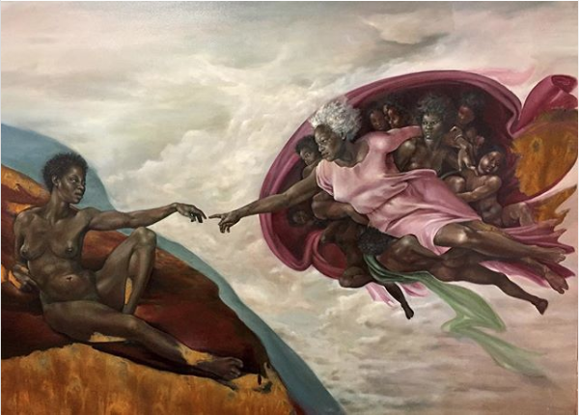
Harmonia Rosales, The Creation of God, 2017. Oil on canvas
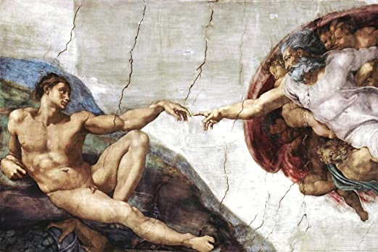

Michelangelo, The Creation of Adam, 1508-1512. Ceiling painting

